

Please bring your application reference code to your class teacher so we can log it for our reference.

Reminder:
Please return you letter with your up-to-date information by
Monday 29th September.
These letters were given out this week.
Thank you
PARENTS’ Consultation to meet the teachers will take place from Monday 19th October to Friday 23rd October.
Word Of the Week: Explore
Please ask your child: “What did you explore today?” Encourage them to use the word at home.



Nursery Weekly Newsletter

Mrs Aboobaker. Miss Moore
Mrs Mehta, Mrs Ruprai,
Mrs Arora, Miss Morgan,
Miss James
Mrs Javed, Miss Baamer

Please view all links on the website:
www.yeadinginf.co.uk
and visit the Instagram account
https://instagram.com/yeading_infants
You will find all school information,
Updates, term dates and up & coming events

Date: 02.10.2026

Hello Parents and Carers!
We are very happy with how the children are settling into their Nursery routine and starting to play together.
Our Learning
This Week | Next Week
The children have been listening to instrumental sounds. This is fun and interactive learning which encourages and develops the children’s listening skills.  We have continued to discuss sharing and having kind hands and feet when playing with our friends.  Your children are having toileting accidents so please provide a change of clothes for them in a bag labelled with their name. Thank you!  All children should also have a water bottle with their names on.  We also would like to show you a helpful website regarding speech and language. Please do have a look:  www.cnwl.nhs.uk/application/files/9715/8167/7857  / Development_Tool_for_Referral.pdf | Our new focus book is Brown Bear, Brown Bear, What Do You See?  By Bill Martin Jr and Eric Carle  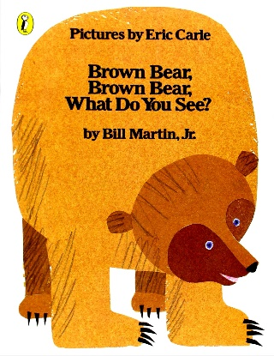  https://www.youtube.com/  watch?v=Mc9My7TnxFU  In Number the children will be starting to look at numerals 1 to 3. You can support your child at home by looking for numerals in your home or on your walk to school. For example, numerals on doors to houses or on buses. We will also be modelling number writing.  The children will be learning about Autumn and what makes it special.

General Notices
Donations
Thank you for all donations received.
We are planning to do lots of cooking over the next few terms in Nursery. For us to be able to do this we kindly ask for your donations of £1 so that we can purchase ingredients. The money will also go towards ingredients for sensory play such as making Playdough, Cloud Dough, Rainbow pasta and more. These are all important for your children’s development!

Library Books
Please can we ask that every child has a school book bag. This week we have started to give children a library book to take home. The library book will be changed every week. Please do not draw, tear or lose the library books. Thank you
Happy reading!

Home Time
Please can parents queue in single file at the doors when collecting.
Your child’s safety is extremely important to us. We ask that you form a queue and continue to be patient when we are calling your children’s names. If somebody different is picking up your child, you must inform staff or call the school before pick up time. We will not send your child home if you do not inform staff of any changes. Therefore, please let us know in advance.

Health & Hygiene
Children should be entering the nursery without nappies or pull-ups. Please support children at home by encouraging them to be independent when going to the toilet. The Children’s Centre (next door) may be able to provide support to parents in this area. We ask you to register with them as quickly as possible.
We ask that you teach and show children how to properly clean their runny noses so that we can limit germs spreading within Nursery.

Punctuality & Absence
If your child is going to be absent, for whatever reason, please ensure that you ring the school office by 8.40am on 020 8573 3389 pressing option 1 and leaving a message, stating your child’s full name, class, and reason for absence.
Thank you, Nursery staff

