Curriuclum meeting
Thank you to all parents for attending our Curriculum Meeting on Wednesday. Please complete the parent questionnaire below.
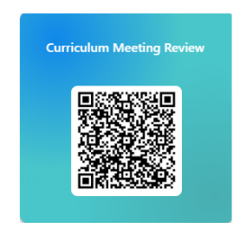
Oracy October 2026 is a month-long, nationwide celebration of oracy (speaking, listening, and communication skills) in the UK, organized by Voice 21. This is a high-quality oracy education programme which builds a sense of belonging, strengthening disciplinary knowledge across the curriculum, as well as creating a rich school environment that is inclusive for all.


Celebrating diversity through Black History Month in the UK
The achievements and contributions of Black British people have been celebrated during October, as the United Kingdom marks Black History Month.
Theme for Black History Month 2026 is 'Honouring Our Communities. Children will be encouraged to learn about and celebrate the achievements, contributions and experiences of Black people in the UK and around the world.



Infant & Nursery School
Year 1
Weekly Newsletter
2nd October 2026
Please visit us on our website:www.yeadinginf.co.uk
and Instagram account
https://instagram.com/yeading_infants
You will find all school information,
Updates, term dates and up & coming events
Good attendance = Success, Friendships,
Confidence & Bright Futures

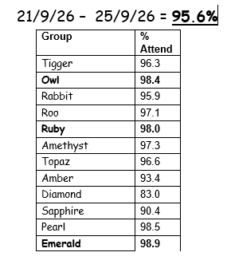
Whole school attendance
!

Literacy
This week we have been writing the beginning, middle and end of the story using lots of adjectives and time connectives.
Next week we will be focusing on our story “Handa’s surprise”. The children will be retelling the story and describing a new character.
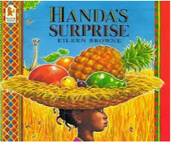
Keywords: Title – Character – Setting – Beginning – Middle – End – First – Next – After- Then- Finally -Time Connectives-Adjectives
Maths
This week we have been looking at doubles and halves within ten/One more, one less
Next week we will be comparing Addition and subtraction within ten

Science: Seasons
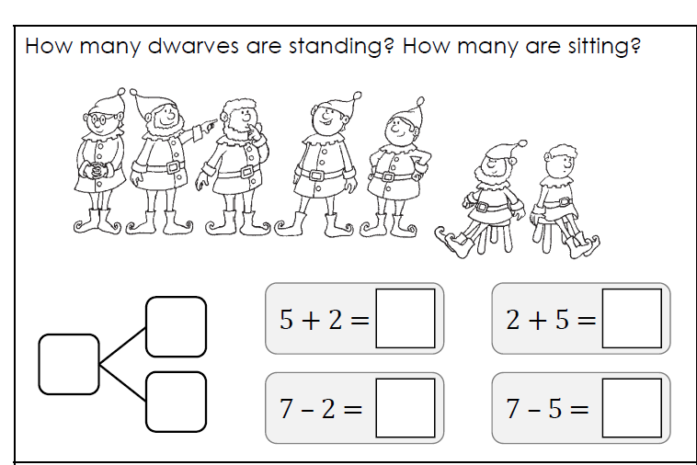
Foundation Subjects
Music- Pulse, pitch & rhythm
History – My family
R.E. – Islam/Harvest Festival
PSHE – Positive Thinking
Art– following instructions to create a drawing.
Computing- Digital Technology
PE- Every Wednesday- For all year 1 classes
Additional sessions will take place on Thursdays for all Year 1 classes.
Question of the week
How can I be a good friend?
Word of the week
Improve
Write a sentence explaining the meaning of our word of the week.

Harvest Festival
Harvest
Please could you donate a food item to support our ‘Harvest Festival’ celebration on Tuesday 6th October. The letters have been sent home. Please check in your child’s book bag.
Please practise our song: The farmer gathers his hay today
https://www.bing.com/videos/riverview/relatedvideo?q=the%20farmer%20gathers%20his%20hay%20today&mid=CDE18D8043C811E6B1C4CDE18D8043C811E6B1C4&ajaxhist=0
A gentle reminder to all parents to please hand in your £1.00 cooking money. Phone-free zone – Yeading Infant School is a phone-free zone. Please ensure phones are put away while collecting your child.
- Homework is given out on a Friday and to be returned to the to the teacher on the following Wednesday.
- Early morning soft starts are on Tuesdays and Thursdays. Parents will be allowed into the classroom to help their child learn with guidance from their class teacher at 8:45-9:00am
- A polite reminder
- You must ensure you arrive to school by 8.45am. Lateness has devastating effects on teaching and learning process in the school which has negative impacts on school standards, pupils’ academic performance, absenteeism and distractions for other pupils.
- World Mental Health Day – This will take place on the 10th October. The children can come into school wearing one item that is yellow to mark the occasion.
Phonics screening papers
https://www.tes.com/teaching-resource/2012-2013-2014-2015-2016-2017-2018-2019-past-phonics-screening-papers-6453073
USEFUL WEBSITES
Phonics screening papers
- https://www.tes.com/teaching-resource/2012-2013-2014-2015-2016-2017-2018-2019-past-phonics-screening-papers-6453073

- Phonics - https://home.oxfordowl.co.uk/reading/reading-schemes-oxford-levels/read-write-inc-phonics-guide/
- Mr Thorne Does Phonics with Geraldine the Giraffe on YouTube- https://www.youtube.com/channel/UC7sW4j8p7k9D_qRRMUsGqyw
- Phonics play - www.phonicsplay.co.uk
- Top Marks - https://www.topmarks.co.uk/english-games/5-7-years/letters-and-sounds
Have a good weekend! Year 1 Team

